The whole sample is modified based on the vulkan sample here with vs2015. https://github.com/LunarG/VulkanSamples
15-draw_cube sample is used as vulkan drawing part. Openvr sdk is merged for submitting images to vive.

Qualification for this sample:
- Familiar with Openvr sdk;
- Familiar with vulkan pipeline;

Here are things you should know:
- Make sure your computer support vulkan. https://developer.nvidia.com/vulkan-driver.
- Open 15-draw_cube sample and run, then you can see the result with vive;
- Find util_init.cpp at “..\VulkanSamples\API-Samples\utils” and look at Init_instance_extension_names() function. One extension is added here according to the doc here. https://github.com/ValveSoftware/openvr/wiki/Vulkan.
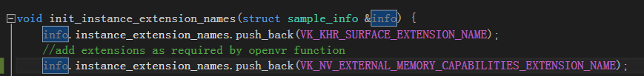
Extension for device init also should be added in init_device_extension_names(). But for now it is empty. So nothing is added. For future consideration, codes needs modified here, not just hardcode the result.
- CMainApplication class contains the openvr sdk (not all of it, but codes related to submit images to vive). Headers and lib are put directly into the project folder and should add path reference to them at the vs2015 project configuration. Win 32 dll files of openvr sdk is added to the debug folder (..\VulkanSamples\build\API-Samples\Debug) or depending on you building target platform, win64 dll should be used.
- This is just a sample now which mainly focus on submit vulkan images to vive with openvr sdk. A lot of other work could be done to make it more like a formal project, but for now, it is best used for learning before Valve’s formal sample added to openvr sdk (if there will be).

Emai: Tim.w_xu@htc.com

